SMART IRRIGATION SYSTEM

## A MINI-PROJECT REPORT

***Submitted by***

|  |  |
| --- | --- |
| **RITHIKA M** | **210701214** |
| **SELVANANDHINI S** | **210701237** |

***in partial fulfillment of the award of the degree of***

# BACHELOR OF ENGINEERING

**IN**

**COMPUTER SCIENCE ENGINEERING**



# RAJALAKSHMI ENGINEERING COLLEGE, AUTONOMOUS ,CHENNAI 600 025

## MAY 2024

**BONAFIDE CERTIFICATE**

Certified that this project **“SMART IRIRGATION SYSTEM”** is the bonafide work of **“RITHIKA(210701214) , SELVANANDHINI (210701237)”** who carried out the project work under my supervision.

|  |  |
| --- | --- |
| **SIGNATURE** | **SIGNATURE** |
| **Dr. P. KUMAR, M.E., Ph.D.,** | **Miss Anitha Ashishdeep,M.tech** |
| **HEAD OF THE DEPARTMENT** | **SUPERVISOR** |
| **PROFESSOR** | **PROFESSOR** |
| Dept. of Computer Science and Engg, | Dept. of Computer Science and Engg, |
| Rajalakshmi Engineering College,  Chennai - 602105 | Rajalakshmi Engineering College,  Chennai - 602105 |

Submitted to Project Viva-Voce Examination held on 21-05-2024

**INTERNAL EXAMINER EXTERNAL EXAMINER**

## ABSTRACT

Agriculture is the most important profession and worship in India. Agriculture is the livelihood of most Indians living in rural communities. Smart irrigation helps agriculture and rural areas. In India, agriculture accounts for 16% of total GDP and 10% of total exports. Water plays an important role in agriculture. Irrigation is a method of providing water. In this water system, people waste more water due to lack of time. So we have a nice method called smart irrigation system that uses IoT to save water and time. We use many products such as temperature sensors, humidity sensors and soil moisture sensors in smart irrigation systems. These sensors will detect various conditions in the soil and automatically pump water into the soil based on the moisture percentage of the soil. This means that the engine will start when the field needs water, the engine will turn off when there is enough water and the water flow will be less if it is greater than threshold value little bit . This reduces the water wastage and monitors the plant health by maintain its health because it the water is plenty the plant gets spoiled and if the water is less the plants may get withered and it may also lead to soil erosion.

## ACKNOWLEDGEMENT

First, we thank the almighty god for the successful completion of the project. Our sincere thanks to our Chairman **Mr. S. Meganathan, B.E., F.I.E**., for his sincere endeavor in educating us in his premier institution. We would like to express our deep gratitude to our beloved Chairperson **Dr. Thangam Meganathan, Ph.D.,** for her enthusiastic motivation which inspired us a lot in completing this project and Vice Chairman **Mr. Abhay Shankar Meganathan, B.E., M.S.,** for providing us with the requisite infrastructure. We also express our sincere gratitude to our college Principal**, Dr. S.N. Murugesan M.E., PhD.,** and **Dr. P.Kumar M.E., Ph.D.,** Head of the Department of Computer Science and Engineering and our project guide **Mrs. Anitha Ashishdeep, M.E.,** for his encouragement and guiding us throughout the project and to our parents, friends, all faculty members and supporting staffs for their direct and indirect involvement in successful completion of the project for their encouragement and support.

**RITHIKA M**

**SELVANANDHINI S**

**TABLE OF CONTENTS**

|  |  |  |
| --- | --- | --- |
| **CHAPTER NO** | **TITLE** | **PAGE NO** |
| **1** | **INTRODUCTION** | 5 |
| **2** | **LITERATURE SURVEY** | 6 |
| 2.1 | EXISTING SYSTEM | 8 |
| **3** | **PROJECT DESCRIPTION** | 10 |
| 3.1 | PROPOSED SYSTEM | 11 |
| 3.2 | REQUIREMENTS | 11 |
| 3.2.1 | HARDWARE REQUIREMENTS | 12 |
| 3.2.2 | SOFTWARE REQUIREMENTS | 12 |
| 3.3 | ARCHITECTURE DIAGRAM | 13 |
| 3.4 | OUTPUT | 13 |
| **4** | **CONCLUSION AND FUTURE WORK** | 16 |
|  | **APPENDICES** | 17 |
|  | **REFERENCE** | 20 |

# CHAPTER 1 INTRODUCTION

India is one of the most populous countries in the world. The most important source of income for India to have a good economy is agriculture. In India, agriculture provides employment to approximately 70% of the population and is the source of 25% of GDP. Agricultural income. Irrigation has an important place in agriculture.

Water is the immense resource that we need in our day to day life. We must do our best to save money in order to overcome the country's water scarcity problem. We must use the water in a systematic way to control the water scarcity problem. Unnecessary water wastage should be avoided.

Farmers always irrigate with manual control. During that period, they irrigated the land with the assumptions they make based on their experience of prediction. If this situation continues, the world will face many water shortage problems due to the increasing food demand of the population. We must manage water by using water correctly.

This smart irrigation system is very useful if we are a beginner. The soil moisture sensor will find the moisture percentage present in the soil. The engine will then start if the moisture percentage is low and less speed when the percentage is less than sufficient and stops when it is accurate to the threshold. The pump and the motor used here controls the speed of the water flow.

# CHAPTER 2 LITERATURE SURVEY

1. Kim et al. (2008) presented the first automated irrigation systems using wireless sensor networks (WSNs) which is used monitor soil moisture and control irrigation based on real-time data .The water flow was controlled based on the analog readings from the soil moisture sensor and the pump which has a DC motor.

2. Bogena et al. (2010) discussed the integration of soil moisture sensors with wireless networks, demonstrating significant water savings and improved crop yields .The integration paved the way to save water and to monitor the plant health. This encompasses the range of devices and protocols that facilitate the collection ,transmission, and analysis of data.

3.IoT in Agriculture: Enhancing Irrigation Efficiency. This tells us about the various modern irrigation technologies that saves water rather than the old irrigation system. This also tells us about the various methods of modern farming.

4. Wang, X., & Zhang, Y. (2019). "Wireless Sensor Networks for Smart Agriculture. This tells us about the various wireless sensor networks used for smart irrigation. This also tells us about the smart irrigation technologies used using the wireless sensor networks example wifi.

5. "Arduino-Based Smart Irrigation System." (2020). Retrieved from Arduino reference page tells us the GPIO pins needed and voltage pins required and also the ground pin for the execution of the project. This shows us the model of connections to be made.

6. A study by Johnson et al. (2017) implemented a smart irrigation system in vineyards, resulting in a 20% reduction in water use and improved grape quality .This system used the smart irrigation technologies used to improve the plant health which resulted in increased grape quality and quantity.

7. "Design of Automatic Irrigation System Based on Soil Moisture Sensor and Remote Control. This tells us to monitor the plants remotely at continuous levels. This is done by the soil moisture sensor which measures the moisture present in the soil and act accordingly.

8. Smart Urban Gardening Using IoT. This focuses on not only the large scale farming but also for the gardeners who are beginners and who want to cultivate in small scale. This helps us to modify the water flow automatically in today world’s busy schedule.

# EXISTING SYSTEM

Existing smart irrigation systems using soil moisture sensors have been developed to address the inefficiencies of traditional irrigation methods. These systems typically consist of sensors that measure soil moisture levels, controllers that process the sensor data, and actuators (such as valves and pumps) that automate the irrigation process. Here is an overview of some notable existing systems:

1. Netafim Precision Irrigation: Netafim provides advanced solutions for agriculture. Netafim is known for its innovation, such as drip and micro-irrigation technologies, which is designed to improve water level and nutrient content in plants, thereby increasing crop yields and saving water. The systems feature has advanced drip lines that send water directly to the plant's root , increasing water efficiency and reducing . Netafim uses energy-compensated drippers to ensure even distribution of water despite pressure changes. Integration of soil moisture sensors and weather stations provides instant information to help optimize irrigation schedules. Netafim's NetBeat platform combines monitoring, analysis and electricity usage using sensor data and weather forecasts to improve water quality. Automatic valves can be controlled remotely to obtain pure water. Additionally, Netafim's fertilization system maximizes yield by delivering fertilizer directly to the roots. It specializes in smart irrigation technology as its solutions are designed for different types of agriculture, including open fields, orchards and greenhouses.

2. GreenIQ Smart Garden Hub: This offers a hub of garden which connects to variety of sensors and devices to optimize irrigation and water wastage.It uses the soil moisture levels and plant type information to adapt to watering schedules.The hub can be controlled through mobile app or wifi.

3. Hunter Hydrawise is a smart irrigation system designed to improve water use in the landscape, garden and lawn using technology and real-time data. It includes local weather data such as precipitation, temperature and humidity to adjust irrigation schedules to ensure watering occurs only when necessary. This system not only saves water it also prevents overwatering to the plants which affects the plant health. Users can manage and monitor their water flow of the plant through a user-friendly mobile app or web interface which provides real-time updates and notifications based on the plant condition. The Hydrawise system supports efficient water use and plant growth by making it easy to control watering times from anywhere.

4. Eve Aqua: Eve Aqua is a smart controller of water for home and gardens that connects to an outdoor water supply pump and can be controlled from home using mobile and wifi.It uses moisture levels of soils to schedule the water supply to plants.

5. CropX: This system offers soil sensor systems and cloud-based analytics to give accurate irrigation solutions for agriculture. Their system analyses the moisture through data collected from soil moisture sensor ad activate the motor to pump the water to plants.

6. The Blossom Smart Water Controllering irrigation technology :where the users can reduce the usage of water in watering plants in the garden. It utilizes real-time weather data and real-time irrigation schedules. It can be controlled by a smartphone app, where the users can manage and monitor water usage from their devices. Utilizing the app, Blossom tracks local weather patterns and prior data to alter the watering time. Blossom ensures that plant roots are continually watered a sufficient quantity of water and allows them to grow.

# CHAPTER 3 PROJECT DESCRIPTION

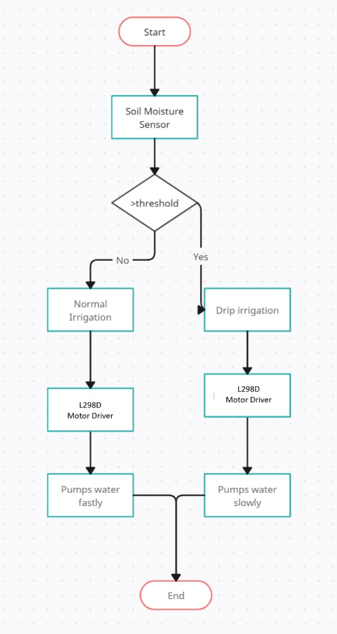

## PROPOSED SYSTEM

## The proposed system combines an ESP32 microcontroller with a soil moisture sensor to detect soil moisture effectively. Sensor data is transmitted wirelessly to the Blynk app through Wi-Fi, enabling seamless real-time monitoring of the plant moisture level on users' smartphones. The ESP32 firmware processes sensor readings, promptly triggering the pump using the batter when soil moisture level surpass predetermined thresholds, ensuring swift responses to the decrese in soil moisture level. The flow of the water is also controlled by the condition,when the moisture level is below 20 percent of the threshold the flow of water is minimum,if the moisture level is zero the flow of water is high and when the moisture level reaches the threshold the water flow stops This IoT-based solution offers significant advantages, including remote monitoring capabilities, enhanced safety measures, and proactive risk mitigation. By leveraging the ESP32's robust wireless communication capabilities and integrating with the user-friendly Blynk app, the system provides an accessible and reliable means of monitoring the soil moisture levels remotely anywhere through mobile, empowering users to monitor plants health and water levels to increase the supply and improve the lant health.

## REQUIREMENTS

### HARDWARE REQUIREMENTS

1. ESP32 Development Board
2. Soil moisture sensor
3. Power Supply (USB adapter, battery pack, or power supply module)
4. Blynk-Compatible Device (smartphone or tablet)
5. Pump
6. Wiring and Breadboard
7. L298d motor driver

### SOFTWARE REQUIREMENTS

* + - * Blynk app
      * Arduino ide

## ARCHITECTURE DIAGRAM

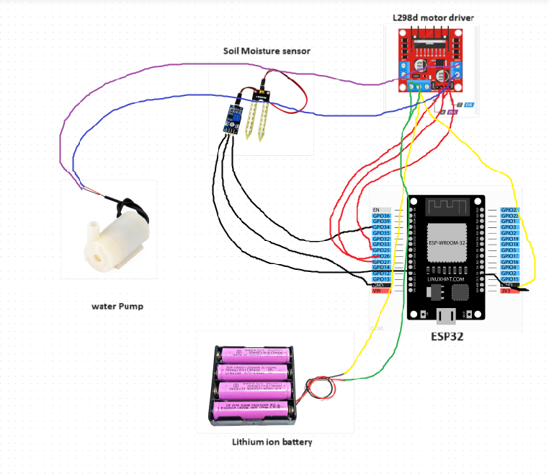

### Figure 2

## OUTPUT

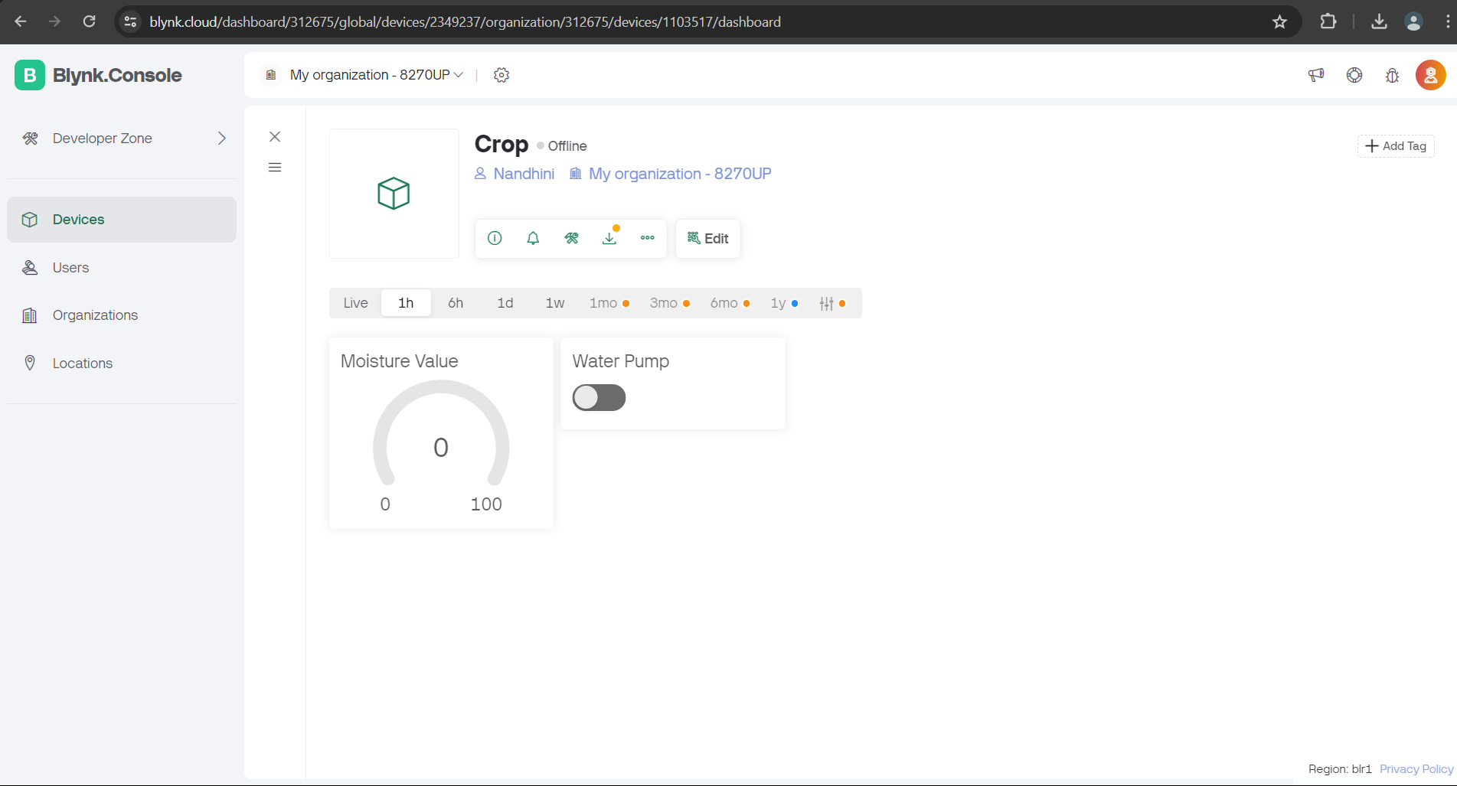

Figure 1. Showing water level in Blynk console

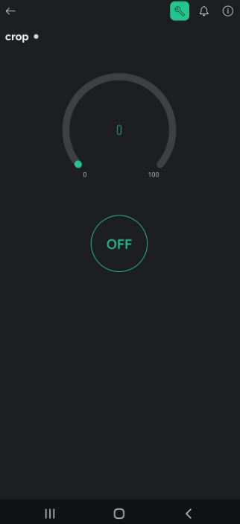

Figure 2.Realtime data in blynk iot app

CONNECTIONS:

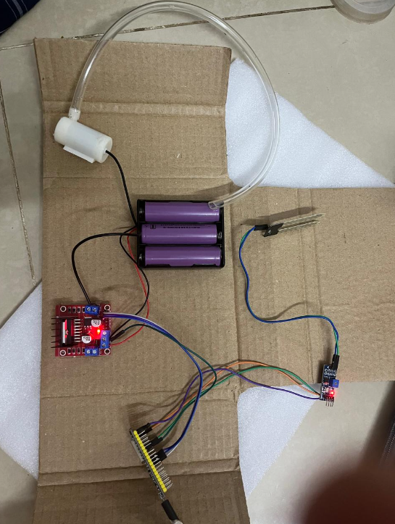

**Figure 3**

Figure 3 shows the connections made to the sensor and motor driver with the ESP 32 The connections are provided as specified in the architecture.

## CHAPTER 4 CONCLUSION AND FUTURE WORK

In conclusion, the integration of ESP32 with soil moisture sensor to detect leak soil moisture levels, coupled with the Blynk app, offers an efficient and accessible solution for enhancing irrigation system and to control water wastage. Real-time monitoring and irrigating the plants at correct interval with adequate amount of water improves the plant health and increases the quantity of the supply.

Future work could focus on optimizing sensor calibration algorithms, enhancing the system's reliability, and exploring additional functionalities such as remote control of gas valves or integration with smart home automation platforms. Continued refinement of the system's hardware and software components will further advance its capabilities and applicability in diverse settings.

By using advancements in AI and machine learning algorithm we can make predictions and we can also use Natural Language Processing which helps for voice assistance. The DHT sensor is used to measure the humidity and temperature data alongside soil moisture information, helping predict weather conditions and adjust watering schedules automatically. The Latency can also be further reduced for faster processing of the motor so that the delay could be reduced to much greater extend.

**APPENDIX I**

#define BLYNK_TEMPLATE_ID "TMPL3_HOIloWD"

#define BLYNK_TEMPLATE_NAME "crop irrigation"

#define BLYNK_PRINT Serial

#include <WiFi.h>

#include <WiFiClient.h>

#include <BlynkSimpleEsp32.h>

char auth[] = "T9T8Vc2xNrUquTAxgUc_u9BZ6OuX4Hka";

char ssid[] = "realme";

char pass[] = "12345678";

const int soilMoisturePin = 34;

// Define the digital pins connected to the motor driver

const int motorPin1 = 25; // IN1 on the L298N

const int motorPin2 = 26; // IN2 on the L298N

const int enablePin = 27; // ENA on the L298N (PWM)

// Variables to store the sensor reading

int sensorValue = 0;

float soilMoisturePercent = 0.0;

bool manualControl = false; // Flag to indicate manual control state

BlynkTimer timer;

// Function to read soil moisture and update Blynk

void readSoilMoisture() {

// Read the analog value from the sensor

sensorValue = analogRead(soilMoisturePin);

// Convert the analog value to a percentage

soilMoisturePercent = map(sensorValue, 4095, 0, 0, 100);

// Print the values to the Serial Monitor

Serial.print("Soil Moisture Sensor Value: ");

Serial.print(sensorValue);

Serial.print(" - ");

Serial.print(soilMoisturePercent);

Serial.println("%");

// Update the Blynk app with the soil moisture percentage

Blynk.virtualWrite(V0, soilMoisturePercent);

// Control the motor speed based on soil moisture percentage if not in manual control

if (!manualControl) {

if (soilMoisturePercent > 40) {

// Reduced speed before 80%

ledcWrite(0, 50); // 50% speed

digitalWrite(motorPin1, HIGH);

digitalWrite(motorPin2, LOW);

Serial.println("Motor ON: Reduced speed (50%)");

} else {

// Full speed at or above 80%

ledcWrite(0, 255); // Full speed

digitalWrite(motorPin1, HIGH);

digitalWrite(motorPin2, LOW);

Serial.println("Motor ON: Full speed (100%)");

}

}

}

if (motorState == 1) {

digitalWrite(motorPin1, HIGH);

digitalWrite(motorPin2, LOW);

ledcWrite(0, 255); // Full speed when manually turned on

Serial.println("Manual Control: Motor ON at full speed");

} else {

digitalWrite(motorPin1, LOW);

digitalWrite(motorPin2, LOW);

ledcWrite(0, 0); // Turn off motor

Serial.println("Manual Control: Motor OFF");

}

}

void setup() {

// Initialize serial communication

Serial.begin(115200);

// Set motor pins as outputs

pinMode(motorPin1, OUTPUT);

pinMode(motorPin2, OUTPUT);

pinMode(enablePin, OUTPUT);

// Initialize PWM for motor speed control

ledcSetup(0, 5000, 8); // Channel 0, 5kHz, 8-bit resolution

ledcAttachPin(enablePin, 0);

// Initialize Blynk

Blynk.begin(auth, ssid, pass);

// Optionally, you can configure the analog resolution

analogReadResolution(12); // Default is 12 bits (0-4095)

// Setup a function to be called every second

timer.setInterval(1000L, readSoilMoisture);

}

void loop() {

// Run Blynk

Blynk.run();

// Run timer

timer.run();

}

**REFERENCE**

1. Kim, Y., Evans, R. G., & Iversen, W. M. (2008). "Remote Sensing and Control of an Irrigation System Using a Distributed Wireless Sensor Network." IEEE Transactions on Instrumentation and Measurement, 57(7), 1379-1387.
2. Bogena, H. R., Huisman, J. A., Oberdörster, C., & Vereecken, H. (2010). "Evaluation of a Low-Cost Soil Water Content Sensor for Wireless Network Applications." Journal of Hydrology, 344(1-2), 32-42.
3. Li, S., Zhang, X., Wang, X., & Shen, Q. (2015). "Design of Automatic Irrigation System Based on Soil Moisture Sensor and Remote Control." Procedia Engineering, 2015, 923-928.
4. Park, J., Lee, S., & Choi, M. (2019). "Smart Urban Gardening Using IoT: Case Study in a Korean City." Journal of Urban Technology, 26(2), 77-95.
5. Jain, M., Srivastava, A., & Katiyar, S. K. (2020). "Machine Learning Algorithms for Smart Irrigation Systems: A Review." Journal of Artificial Intelligence Research & Advances, 4(2), 45-56.
6. Patil, P. G., & Kale, S. A. (2018). "IoT Based Smart Irrigation System for Rice Fields." International Journal of Modern Trends in Engineering and Research, 5(7), 145-150.
7. Goyal, P., Meena, S., & Singh, Y. P. (2021). IoT-Based Smart Gas Leakage Detection and Alerting System. Wireless Personal Communications, 118, 2211-2224.
8. Jain, M., Srivastava, A., & Katiyar, S. K. (2020). "Machine Learning Algorithms for Smart Irrigation Systems: A Review." Journal of Artificial Intelligence Research & Advances, 4(2), 45-56.
9. Zilberman, D., Gordon, B., Hochman, E., & Wichelns, D. (2019). "Model Predictive Control for Efficient Irrigation Management." Agricultural Water Management, 213, 550-559.